CHAPTER-1
INTRODUCTION

Pets have become an important part of many families today, and their health and safety are major concerns for pet owners. Whenever a pet shows unusual behaviour, illness, or discomfort, owners often look for guidance. But visiting a veterinary clinic is not always possible due to distance, lack of time, high consultation costs or unavailability of doctors during urgent situations. Many people also face difficulty finding trusted information online because most sources are general and not specific to their pet’s condition. To solve these challenges, the idea of an online pet consultation system becomes useful. It allows pet owner to connect with veterinary experts through a simple online platform and get basic advice without needing to travel or wait for appointments. This project aims to provide a smooth and accessible digital space where users can ask questions, upload details, and receive suggestions for their pets in reliable manner.

The aim of this mini project is to design and develop a web-based application that makes pet consultation easier, faster, and more organized. The system focuses on convenience, especially for users who may not have immediate access to veterinary services. Through this platform, a pet owner can register, login, and interact with consultants using an easy interface. By online consultation, the user can understand whether the pet needs home care, a simple remedy, or an in-person visit to clinic. This reduces unnecessary trips and helps the user make informed decisions. The system also creates awareness about responsible pet care by making information more reachable. It also supports veterinarians by allowing them to manage queries in a structured way instead of handling scattered messages through calls or social media.

To build the online pet consultation system, we used a combination of backend and frontend technologies. HTML and CSS were used to design a basic structure and appearance of webpages. Bootstrap was added to make the website responsive so it can adjust well on computers, tablets and mobile phones. JavaScript was used to add interactivity and form validations, making the system smoother for users. On the backend python was chosen because it is simple, powerful, and widely used in applications. Python helps in managing user requests, processing data, and handling communication between the frontend and the database. For storing the user information, consultation details and other related data, MySQL Workbench was used. MySQL is a stable and secure database management system that supports large amount of data and makes retrieval fast and efficient.

Overall, this project bring together basic but essential web development concepts to create a meaningful application that solves a real-life problem. The online pet consultation system is not only a technical project but also a practical tool that shows how digital platforms can improve daily life. By connecting pet owners and experts through a simple online platform, the system contributes to better pet care and promotes the use of technology in routine services. This introduction highlights the purpose, need and technologies used in the project creating a foundation for detailed chapters that follow in the full report.

CHAPTER-2
LITERATURE SURVEY
1. Introduction to online consultations systems:
Online consultations systems have become increasingly common in different service sectors such as healthcare, education, banking, banking, customer support. Researchers have highlighted that internet-based consultation platforms reduce physical barriers and help users access expert advice more quickly. Early studies mainly focused on improving human-to-human communication through emails and chat interfaces, but later research expanded into interactive web portals, automated responses, and real-time communication tools. Many authors state that online consultation systems offer flexibility, time savings, and easier communication for users, especially in situations where immediate physical access to services is difficult. These findings laid the foundation for building similar systems in specialized fields such as veterinary care.
As online service delivery continued to grow, researchers began examining the technological frameworks, user interface designs, and decision support mechanisms that improve the effectiveness of consultation systems. Several studies emphasized that the reliability of such systems depends not only on the availability of experts but also on the integration of knowledge bases, also automated query systems, and structured communication modules. Scholars also pointed out that user satisfaction increases when platform provide clear navigation, guided question prompts, and multimedia support such as images or short videos to clarify user concerns. Additionally literature from the past decade shows an increasing trend toward incorporating machine learning to filter queries, prioritize urgent cases, and generate preliminary suggestions before expert review. These developments indicate that online consultation systems have evolved from simple messaging tools to intelligent, semi-automated platforms capable of supporting diverse service needs.
2. Development of web-based healthcare platforms:
Several studies have examined the importance of telehealth and virtual medical consultation. According to past research, online healthcare system support users in obtaining basic guidance, scheduling appointments, and remotely connecting with doctors. These systems became especially significant after the rise of digital technologies and the increased use of smartphones and high-speed internet. Literature shows that telehealth reduces the burden on hospitals by filtering minor issues that can be solved without physical visits. Researchers observe that such system improve accessibility for people in rural areas and help in early identification of health problems. These advantages inspired the development of adoption-specific systems like online dental care, mental health support, and dermatology consultations.
Further literature highlights that the effectiveness of web-based healthcare platforms largely depends on the integration of secure data management, user-friendly interfaces, and reliable communication technologies. Researchers note that as telehealth platforms evolved, the focus shifted toward improving patient engagement through features such as electronic health records, automated remainders, symptom checker, and real-time chat or video support. Studies also emphasize the importance of privacy and data protection, as user are more likely to adopt these systems when they trust the platform with their personal health information. Moreover, recent work shows that artificial intelligence has begun playing major role in enhancing diagnostic accuracy and providing preliminary assessments before consultation with medical professionals. These advancements demonstrate that web-based healthcare platforms are no longer limited to simple online communication but functioned as sophisticated digital ecosystems that support continuous remote patient care.
3. Emergence of digital veterinary services:
Although human healthcare platforms grew early, digital veterinary consultation systems began receiving attention later. Studies explain that pet owners often struggle to reach veterinarians quickly, especially during emergencies or outside working hours. Research also mentions that veterinary clinics are limited in many regions, causing delays in treatment. Academic papers and articles identify that online veterinary services can fill this gap by providing initial suggestions, storing pet medical histories, and offering preventive care information. Some early systems allowed basic chat interaction while later models introduced image-sharing, symptoms checklists, and automated response tools. Literature consistently supports the need for online systems that help pet owners make better decisions regarding their animals’ well-being.
Moreover, recent literature highlights that the rise of digital veterinary services is closely linked to the growing awareness of pet health and the increasing number of households adopting pets. Researchers have observed that modern pet owners expect quicker access to professional advice, similar to the convenience offered in human telemedicine platforms. This demand encouraged the development of more advanced tools, such as AI-based symptom analysers, video-call consultations, online prescription support, and platforms that track vaccination schedules or dietary requirements. Several studies also emphasize that the digital veterinary systems improve continuity of care by allowing veterinarians to monitor pets over time through stored health data and follow-up interactions. As technology continues to evolve, experts believe that digital veterinary platforms will become an essential extension of traditional clinics, offering timely guidance and reducing stress for both pets and their owners.
4. Importance of technology in pet healthcare:
Research highlights that pets require continuous health monitoring similar to humans. Multiple studies mention that pet owners often turn to the internet for solutions, but general websites cannot replace veterinary expertise. This gap led to the concept of structured digital platforms created specifically for pet care. Research papers emphasize that proper technological tools can help owners detect early signs of illness, follow vacation guidelines, manage diets, and understand behavioural changes. Scholars also point out that many pet-related problems become severe because owners fail to notice symptoms early. Online consultations systems can guide pet owners towards timely action by providing instant responses and organized health information.
Further studies underline that the integration of modern technologies-such as mobile applications, cloud databases, wearable health trackers, and automated alert systems-has greatly strengthened the field of pet care. Researchers note that these tools offer real-time insights into a pet’s activity levels, sleep pattern, feeding habit, and overall behaviour, which can help in predicting potential health issues before they become critical. Literature also suggests that when the digital tools are combined with professional veterinary guidance, the accuracy of early detection significantly increases. Additionally, technology driven platforms create a bridge between veterinarians and pet owners by ensuring that medical records, prescriptions, and consultation histories are easily accessible at any time. This improves long time care, enhances communication, and reduces the chances of mismanagement of treatment. As a result, technological innovation is considered a crucial factor in modernizing and improving the overall quality of pet healthcare services.

5. Existing online consultation tools and their limitations:
While reviewing existing digital consultation tools, researchers have identified several limitations. Many platforms are not user friendly and lack simple navigation for ordinary users. Some have complicated login systems while others do not support interactive communication. Studies also note that many veterinary consultation websites do not store long-term medical history, which limits continuous monitoring. Another major issue is the lack of personalized suggestions. Most platforms provide general advice rather than understanding the specific condition of the pet. These limitations show the need for improved systems with better architecture, better database management, and well-structured user interfaces.
In addition to these challenges, literature also points out that many existing online consultation tools struggle with technical reliability, such as slow responsible times, poor mobile optimization, and limited support for multimedia inputs like images or videos features that are essential for accurate veterinary assessment. Researchers emphasize that without such capabilities, platforms fail to capture crucial details a pet’s symptoms, leading to incomplete or inaccurate guidance. Another noted limitation is the weak integration with backend systems, resulting in inconsistent data storage and difficulty in retrieving past records. Security concerns, such as inadequate data protection and lack of encrypted communication, have also been highlighted as major drawbacks in older platforms. Scholars argue that for an online consultation system to be truly effective, it must provide seamless interaction, robust data handling, personalized recommendations, an strong privacy measures. These gaps in existing tools underline the growing need for more advanced, secure and user-centred veterinary consultations systems.
6. Related research on web development technologies:
Research related to frontend technologies such as HTML, CSS, Bootstrap, and JavaScript shows that these tools form the foundation of modern web applications. HTML provides the structure of web pages, CSS improves appearance, Bootstrap helps create mobile friendly responsive designs. JavaScript adds dynamic behaviour and handles various client-side interactions. Academic writings on web development emphasize that using these technologies together leads to clean, interactive, and user-focused interfaces. This combination is widely used in student projects, e-commerce platforms, and professional web applications due to its simplicity and effectiveness.
Further literature highlights that the effectiveness of any web-based system depends not only on frontend technologies but also on the backend and database layers that support the application. Studies explain that backend languages like python enable smooth server-side processing, logical operations, and data handling, which are essential for real-time consultation platforms. Researchers also emphasize the importance of integrating structured databases such as MySQL, as they help store user information, consultation history, and system records in a organized manner. Many academic papers point out that when frontend framework are combined with strong backend technologies, the resulting systems become more efficient, secure, and scalable. This integrated approach is widely adopted in modern projects because it enhances overall performance, ensures smooth communication between components, and improves the user experience. As a result, these web development technologies collectively from the backbone of robust platforms like online consultation systems.
7. Backend development and server-side programming:
Python is one of the most researched backend programming languages. Literature explains that python is popular for web development due to its readability, large community support, and strong frameworks. Studies show that python-based applications are easier to maintain, scale, and modify. Research also highlights that python provides better data handling and supports smooth communication between the client interface and the database. In online consultation systems, python is widely used for authentication, from handling, storing consultation records, and communicating with database.
Researchers also point out that python’s backend frameworks offer built- in tools for routing, form validation, session management, and handling HTTP requests, which makes backend development more structured and efficient. Literature also discusses that python integrates well with various APIs and external services, allowing developers to add extra features like email notifications, image processing, or automated responses in consultation platforms. Another important point highlighted in studies is that python’s clean syntax reduces the chance of errors, making the development process faster and more beginner-friendly. Because of these advantages, python has become a preferred choice in academic projects, startups, and large-scale enterprise systems, especially in applications that require accurate data processing and secure communication, such as online pet consultation platforms.

8. Database research and importance of MySQL:
MySQL is one of the most extensively documented relational database systems. Research papers explain that MySQL supports structured data storage, query optimization, and secure access control. Many studies point out that MySQL workbench is a helpful tool for designing, visualizing, and managing database schemas. In consultation systems, database store important details like user profiles, consultation history, expert response, login credentials, and uploaded information. Literature emphasizes the need for reliable database design to prevent data loss and enhance system efficiency. The use of MySQL in this project supports stable and fast data handling.
Further literature highlights that the strength of MySQL lies in its ability to handle large volumes data while maintaining consistency and accuracy, which is essential for applications that store sensitive information. Researchers note that MySQL’s support for indexing, foreign keys, and relational mapping makes it suitable for systems where different types of data must remain interconnected, such as linking pet details with consultation records and user accounts. Studies also emphasize that MySQL offers strong backup and recovery machines, ensuring that data remains safe even during unexpected failures. Additionally, researchers have observed that MySQL integrates smoothly with backend languages like python, allowing fast query execution and reducing delays during user interactions. Because of its open-source nature, stability, and high performance, MySQL continues to be widely used in academic, commercial, and cloud-based applications, making it an ideal choice for building a dependable online pet consultation system.
9. Studies on user interface (UI) and user experience (UX):
Several researchers explored the impact of UI and UX in online applications. They found that users prefer websites that are clean, simple, and easy to navigate. Complex interfaces discourage users and reduce the effectiveness of online services. Studies suggest that using Bootstrap, proper spacing, readable fonts, and organized layout improves the user experience significantly. In consultation systems, UI design plays a major role because user needs to quickly submit details and view responsive design submit and submit details view responses. Literature supports the use of responsive design, accessible colour combinations, and minimalistic interface structures.
In addition to these points, recent studies emphasize that a well-designed UI/UX not only improves usability but also increases user trust and engagement, which is especially important in online consultation platforms. Researchers explain that when users feel comfortable with the interface, they are more likely to return to the platform and use its services regularly. Literature also highlights the importance of interactive elements such as clear buttons, smooth from validation, intuitive menus, and proper feedback messages that guide the user during each step. Another key observation in UX research is that users expect consistency across all pages meaning similar colours, layouts, and design patterns must be maintained throughout the website. Poor consistency often results in confusion, especially for non-technical users. Many authors also suggest containing usability testing, where real users interact with the system and provide feedback, as this helps developers refine the interface. Overall, research strongly supports the idea that a simple ,responsive and visually balanced design enhances the effectiveness of online consultation systems and ensures a smooth experience for all users.
10. Security and privacy in online platforms:
Security is a major topic discussed in research related to online consultation systems. Researchers have emphasized the importance of protecting personal data, login credentials, and stored medical information. Studies recommend using secure login methods, encrypted communication, proper validation techniques to prevent unauthorized access. Research on web security also mentions the importance of preventing SQL injection, cross-site scripting, and data breaches. Although this project is mini-project, the literature still encourages implementing basic security practices to ensure a responsible system.
Further literature highlights that maintaining user privacy is just as important as securing the platform technically. Researchers explain that online consultation systems, including veterinary platforms, handle sensitive information such as user identities, pet medical histories, upload images, and expert responses making it essential to follow data protection principles. Studies emphasize the need for role-based access control, where only authorized users such as administrators or veterinarians can view specific data. Additionally, security research points that regular database backups, secure password storage techniques like hashing, and input sanitization significantly reduce the risk of data loss or misuse. Scholars also stress the importance of monitoring server activities and detecting suspicious behaviour, as early detection helps prevent major cyberattacks. Even though the current project is a mini project, a academic writings suggest that adopting these fundamental security measures not only improves safety but also builds user trust and prepares the system for system expansion.
11. Veterinary research on common problems in pets:
Literature in veterinary science discusses the types of health issues commonly faced by pets such as dogs, cats, and domestic animals. Studies reveal that many problems can be diagnosed early if owners receive timely guidance. Common issues include skin infection, allergies, digestive disorders, behavioural changes, and minor injuries. Research also highlights that improper diet and lack of vaccination often lead to preventable diseases. Veterinarians argue that online consultation can help educate owners about preventive measures, early symptoms, and basic home care. This supports the importance of designing the system that allows experts to share timely advice with pet owners.
Further veterinary research emphasizes that many pet-related health problems remain unnoticed because owners are often unaware of subtle behavioural or physical changes in their animals. Studies mention that pets instinctively hide pain or discomfort, making early detection challenging without proper guidance. Literature also highlights that environmental factors such as climate, hygiene, and exposure to external parasites contribute significantly to common illness in pets. Researchers point out that digital platforms can assist by offering structured symptom checklists, season health tips, and remainders for routine care such as deworming, grooming and vaccinations. Several veterinary papers also stress the importance of continuous monitoring, as many chronic conditions like arthritis, obesity, and dental issues progress slowly and can be better managed through regular online follow-up. These findings reinforce the value of digital consultation system that enables pet owners to obtain reliable information, track recurring symptoms, and make informed decisions to improve their pets’ overall well-being.
12. Studies on digital transformation in animal healthcare:
Research shows that digital tools are increasingly being used in veterinary clinics for storing records, managing appointments, and communicating with clients. Several papers mention that telemedicine is slowly becoming part of veterinary practice, although regulations vary by region. Literature highlights that digital transformation helps improve efficiency, reduces paperwork and supports better decision making. Researchers also explain that online platforms reduce unnecessary clinic visits and help veterinarians focus on severe cases. These studies confirm that digital consultation systems have a strong role in modern pet healthcare. Additionally, recent literature highlights that the digital transformation is reshaping how veterinary professionals interact with both pets and their owners. Researchers note that advanced technologies such as cloud-based application, electronic health records, and mobile health monitoring devices are becoming standard tools within modern veterinary practices. These technologies enable veterinarians to maintain long-term medical histories track treatment progress, and access patient information instantly, even during emergencies. Studies also suggest that digital platforms support better collaboration between clinics, allowing veterinarians to share diagnostic reports, laboratory results, and expert opinions more efficiently. Furthermore, research emphasizes that automated appointed remainders, online payment systems, and remote consultations enhance overall service quality and significantly improve client satisfaction. These developments demonstrate that digital transformation is not just an optional upgrade but an essential aspect of contemporary animal healthcare, promoting faster diagnosis, smoother workflows, and more accessible veterinary support for pet owners.
13. Case studies of similar student and academic projects:
Many academic institutions publish student projects related to online consultation systems. These case studies show how students use HTML, CSS, JavaScript, Python, and MySQL to build functional web portals. Literature from such projects explain typical features like login modules, registration forms, user dashboards, data storage, and messaging systems. Researchers highlight common challenges such as form validation, session handling, and database connectivity. These case studies provide insights into how similar systems were designed and what improvements can be made. They strongly support the technical structure used in the online pet consultation system.
Further examination of student and academic project reports reveals that many teams face similar development issues, which helps build clear understanding of practical implementation strategies. Studies note that most student-built consultation platforms begin with simple prototypes but gradually integrate advanced features such as automated email alerts, responsive email alerts, responsive interfaces, password recovery options, and secure login mechanisms. Many case studies also compare the performance of different backend frameworks and highlight why python and MySQL are preferred for small to medium sized web applications. Researchers observe that documentation from previous student projects often stress the importance of clean database design, modular coding practices, and proper testing before deployment. These academic works also outline lessons learned, such as the need for user-friendly interfaces, improved error handling, and enhanced mobile responsiveness. Together, these case studies not only validate the technology choices used in the online pet consultation system but also provide practical guidance for improving its functionality and reliability.
14. Limitations identified in previous research:
While many platforms exist, literature identifies several limitations:
- Lack of personalized consultation
- Poor user experience
- Limited features for storing pet history
- Unorganized interface
- Limited accessibility on mobile devices
- Slow loading times
- Confusing navigations
- Lack of reliable expert responses
- Many systems do not provide personalized advice based on the pet’s specific condition.
- User interfaces are often confusing, cluttered, or difficult to navigate.
- Features for storing long-pet medical history are missing in several platforms.
- Several consultation tools are not optimized for mobile devices.
- Slow loading speed reduces user satisfaction.
- Some platforms lack proper database organization, causing data retrieval delays.
- Limited real-time interaction options like chat or instant messaging.
- Security features such as encrypted login or secure data handling are often weak.
- No support for multimedia uploads, which are important for diagnosis.
- Lack of proper testing leads to errors and bugs during use.
- Many systems do not offer remainders or follow-up notifications.
- Older platforms are not scalable and cannot handle more users or data efficiently.
Researchers suggest addressing these limitations in new system through improved design, modern technologies, and structured data storage. The proposed project incorporates these recommendations to create a better and more efficient system.

15. Contribution of the proposed project in the context of literature:
Based on the literature reviewed, it is clear that:
- Online consultation is widely accepted and useful.
- Veterinary care needs more digital solutions.
- Web technologies like HTML, CSS, JavaScript, Python, and MySQL are ideal for such systems.
- User prefer simple, responsive, and secure platforms.
- It provides a simple and user-friendly interface, as recommended by UI/UX research.
- The system improves accessibility for pet owners, especially those needing quick guidance
- It supports storing and managing pet medical history, which many previous systems lacked.
- The project addresses the need for digital veterinary services highlighted in multiple studies.
- It offers faster communication between users and experts compared to traditional methods.
- The backend ensures smooth data handling and secure login features, aligning with security research.
- The design follows responsive web standards, allowing use on mobile devices.
- It reduces limitations seen in earlier projects, such as poor navigation and slow loading times.
- The system serves as a practical example for academic projects focused on digital consultation platforms.
Thus, the online pet consultation system contributes to existing research by combining established web technologies with growing need for digital veterinary support. The system addresses gaps identified in previous studies, such as lack of accessibility, weak interface design, and insufficient features for managing health records.
16. Summary of literature survey:
The literature clearly demonstrates the importance of digital technologies in improving communication and providing reliable information. Research supports the design of online consultation systems, especially in fields like veterinary care where quick guidance is essential.
CHAPTER-3
METHODOLOGY
3.1 INTRODUCTION TO METHIDOLOGY
The methodology describes the complete process followed to design, develop, and test the online pet consultation system. Since the project involves both frontend and backend development, the methodology includes steps such as requirement collection, system planning, interface designing, backend programming, database creation, integration and testing. This structured approach ensures that the system is reliable, user-friendly, and aligns with all needs identified during literature review. The methodology also focuses on using simple and effective development tools, making the system easy to maintain and update in future.
The chosen methodology is systematic and divided into several clear stages that helped the team move from an initial area to a web-based platform. Each phase was completed in a step-by-step manner to ensure that errors were reduced and the final system matched the expected functionality. The overall aim of this methodology is to produce functional, responsive, and secure online consultation system for pet owners and veterinary experts.
3.2 PROJECT DEVELOPMENT APPROACH
This project follows a simplified version of the waterfall model, which is widely used in academic software development projects. The waterfall model consists of linear stages such as requirement analysis, design, development, testing, and deployment. The reason for choosing this method is that it is easy to follow, well-structured, and suitable for small to medium projects where the requirements are known in advance.
Each stage in this approach has a well-defined beginning and ending. This helps in maintaining clarity and avoids confusion during the development process. Since the system requirements were clear and stable, the waterfall model helped complete project smoothly without frequent backtracking. The stages of this model as applied to our project are:
- Requirement gathering
- System analysis
- System design
- Frontend development
- Backend development
- Database creation
- System integration
- Testing
- Documentation
By, following this step-by-step approach, the project was completed in an organized manner, reducing errors and improving overall quality of the system.
3.3 REQUIREMENT COLLECTION AND ANALYSIS
Requirement gathering was the first and one of the most important steps in the methodology. At this stage, research was conducted to understand what features are needed in an online pet consultation system. This included reviewing existing systems, studying user needs, and referring to literature on veterinary consultation platforms and digital healthcare tools.
3.3.1 FUNCTIONAL REQUIREMENTS
Functional requirements describe the actions the system must perform. For this project, they include:
- User registration and login
- Separate login access for users and administrators.
- Ability for users to submit consultation queries.
- Option to upload basic pet details.
- Storage of consultation history.
- Admin ability to manage user data and respond to queries.
- Secure handling of form data and login credentials.
3.3.2 NON-FUNCTIONAL REQUIREMENTS
Non functional requirements focus on performance, usability, and security aspects. These include:
- Simple and user-friendly interface.
- Fast load times and lightweight pages.
- Responsive design for mobile and desktop use.
- Proper data validation on both client and server side.
- Secure communication and controlled data access.
- Efficient database queries for smooth data retrieval.
3.3.3 technical requirements
The technologies selected were based on ease of use, reliability, and suitability for web applications.
These include:
- Frontend: HTML, CSS, Bootstrap, JavaScript.
- Backend: python.
- Database: MySQL workbench.
- Tools: code editor (VS code), browser, MySQL server
3.4 system planning
Once the requirements were finalized, system planning was done to understand how different parts of the application would work together. This step involved identifying the modules of the system and planning the workflow of each module.
3.4.1 system modules
The project was divided into several modules for easier development:
- User module: Handles registration, login, and submission of consultation details.
- Admin module: Allows veterinarian or admin to view and respond to user consultations.
- Consultation module: Stores and retrieves consultation questions and answer.
- Pet information module: Helps store basic pet details for future reference.
- Authentication module: Ensures secure access to the system.
3.4.2 workflow planning
A basic workflow plan was prepared to understand how a user moves through the system:
- User visits the website.
- User registers or logs in.
- User enters pet information or submits a consultation query.
- System stores the details in the database.
- Admin logs in views pending queries.
- Admin responds, and the response is shown in the user dashboard.
This clear workflow structure helped during both development and testing.
3.5 system design methodology
System design is the stage where the structure of the system is planned. It includes interface design, backend design and database design. Proper design helps in avoid errors later and ensures that the system is efficient and easy to maintain.
3.5.1 interface design (UI/UX)
The interface design was created using principles learned from UI/UX research. The main goals were:
- Simple, clean layout.
- Easy navigation.
- Readable fonts and proper spacing.
- Minimalistic design with bootstrap.
- Mobile-friendly interface.
- Clear buttons and forums.
Wireframes were first prepared on paper before developing the actual interfaces. This step helped visualize how each page would look.
3.5.2 backend architecture design
The backend design focused on:
- Handling from data securely.
- Connecting to the MySQL database.
- Managing login sessions.
- Processing consultation submissions.
- Sending data to the frontend.
Python scripts were developed to manage these operations smoothly.
3.5.3 database design
The database schema was created using MySQL workbench. Several tables were designed for storing:
- User information.
- Pet details.
- Consultation queries.
- Admin responses.
- Login credentials.
Primary keys, foreign keys, and relationship between tables were planned carefully to avoid redundancy and ensure smooth data retrieval.
2. system architecture
The system architecture defines the overall structure, interaction flow, and major components of the online pet consultation system. It explains how different modules work together to deliver seamless services to the users and veterinarians.
2.1 architecture style
The proposed system follows a three-tier architecture, which includes:
- presentation layer
- developed using HTML, CSS, and JavaScript.
- Provides user-facing screens such as login, registration, dashboard, appointment booking, and chat.
- Handles input validation and user interactions.
- Ensures responsiveness for mobile and desktop devices.
- application layer
- Implemented using python.
- Contains all business logic.
- Manages session control, authentication, and role-based access.
- Communicates between frontend and database.
- Handles form submissions, appointment processing, and consultation workflows
- Database layer
- Managed using MySQL.
- Stores all relevant data: user details, pet records, consultation history, appointments, and messages
- Maintain relationship using structured tables
- Ensures reliable and reliable data retrieval
This layered architecture improves maintainability, scalability, and security of the systems.
3. system workflow
The methodology also includes a detailed workflow that illustrates how users interact with thw system. Each component follows a logical sequence of operations.
3.1 user registration workflow
The user first basic information such as name, email, pet details, and password.
The system performs:
- Client-side validation
- Server-side validation
- Duplicate account checking in MySQL
- Secure password encryption
- User account creation and redirection to login page
3.2 login authentication workflow
After entering credentials:
- Input is sent to backend
- Password is matched using hashed value
- Successful login redirects to user dashboard
- Unsuccessful attempts show error messages
3.3 pet information management workflow
Users can add or update pet records.
The system ensures:
- Proper data formats
- Storage of medical history
- Updating of vaccination details
- Linking each pet with the user account

3.4 appointment booking workflow
Users can select:
- Doctor
- Date
- Time
The backend checks:
- Slot availability
- Conflicts
- User history
- Confirmation
If available, system generates an appointment ID and stores it.
4. detailed module description
4.1 user module
- Registration
- Login
- Editing profile
- Managing pet details
- Viewing doctor list
- Booking appointments
- Sending messages
4.2 veterinarian module
Provides functionalities for doctors:
- Viewing pending appointments
- Checking pet records
- Providing consultation
- Uploading prescriptions
- Responding to chat queries

4.3 admin module
- Managing users
- Managing veterinarians
- Monitoring consultations
- Viewing logs
- Handling complaints
5. database design methodology
A structured database design is essential. The methodology uses the following steps:
5.1 requirement analysis for data
Identification of required fields such as:
- User information
- Pet details
- Doctor profiles
- Appointment slots
- Consultation history
5.2 ER diagram development
An entity relationship diagram shows:
- Entities (user, pet, doctor, appointment, consultation)
- Relationships between them
- Foreign keys for linking tables
5.3 normalization
To avoid redundancy:
- Each table is kept in 3rd normal form (3NF)
- Separate tables for user and pet information
- Unique primary keys
- Efficient indexing for fast retrieval

6. frontend development methodology
6.1 HTML
Defines a skeleton of:
- Forms
- Buttons
- Menus
- Tables
- Inputs
6.2 CSS
Used to style:
- Layout
- Colours
- Fonts
- Buttons
- Responsive design
6.3 JavaScript
Used for:
- Form validations
- Dynamic content loading
- Dropdown filters
- Error handling
- Client-side interactivity
7. backed development methodology
The backend ensures seamless data processing.
7.1 python framework
Using flask/Django, backend handles:
- Routing
- API creation
- Server-side validation
- Database communication
- Data encryption
- Appointment scheduling logic
7.2 business logic implementation
Includes:
- Role-based access
- Authentication
- Logging
- Notification handling
- Appointment algorithms
8. security methodology
To protect user data:
- Password hashing
- SQL injection prevention
- Form sanitization
- Session timeout
- Role-based access control
9. testing strategy
Testing ensures quality and reliability.
9.1 Unit testing
Testing each function individually.
9.2 integration testing
Testing combined interaction between modules
9.3 system testing
Ensuring the full systems runs smoothly
9.4 user acceptance testing
Getting feedback from test users.
10. deployment of methodology
System can be deployed using:
- Local server (XAMPP/WAMP)
- Cloud platforms (AWS)
- MySQL hosting services
Deployment includes:
- Uploading backend files
- Importing database
- Configuring routes
- Performing final testing
11. data flow methodology
To ensure smooth interaction between users, server, and database, the system follows a well-structured data flow methodology. This helps maintain clarity, reduce errors, and improve system performance.
11.1 data flow process
The data flow can be understood in sequential phases:
1. user input phase
User interact through forms, buttons, chat boxes, and selection menus. The data entered undergoes basic client-side validation.
2. request transmission phase
After validation, the data is sent to the backend using HTTP methods (GET/POST).
Example: login details use POST to avoid exposing credentials.
3. backend processing phase
The backend receives the data and performs:
- Data sanitization
- Authentication
- Business logic execution
- Interaction with database
4. database query phase
The backend sends queries to MySQL:
- Insert
- Update
- Delete
- Select
5. response phase
Once the processing is complete, backend sends the final output to the frontend such as:
- Success message
- Error message
- Updated dashboard
- Consultation details
6. user display phase
The frontend formats and presents the response using HTML/CSS.
12. detailed interaction between modules
12.1 user backend interaction
- User sends inputs through forms
- Backend verifies and stores data
- User receives confirmation messages
- Example: pet record submission
12.2 backend database interaction
- Backend acts as mediator
- SQL queries are generated automatically
- Secure connections ensure data safety
- Results are returned in structured form
12.3 user veterinarian interaction
- Users request appointments
- Veterinarians view pending cases
- Consultation notes are uploaded
- Messages flow through secure communication channels
12.4 adminsystem interaction
- Admin monitors system operations in real-time
- They can regulate user behavior
- Admin handles updates, complaints, and database corrections
13. software development life cycle (SDLC) approach
The methodology uses a structured SDLC model.
A combination of waterfall + incremental approach is followed to ensure and stability and flexibility.
13.1 requirement analysis
- Identification of platform purpose
- Understanding user needs
- Determining features
- Creating requirement documentation
13.2 system design
- Designing UI layouts
- Preparing architecture
- Drawing ER diagrams
- Planning database tables
- Structuring backend logic
13.3 development
- Frontend coding
- Backend coding
- Database creation
- Integration of modules
13.4 testing
- Unit testing
- Integration testing
- System testing
- User acceptance testing
13.5 deployment
- Hosting the application
- Configuring database error
- Testing live environment

CHAPTER-4
IMPLEMENTATION
4.1 Technologies Used
- Frontend: HTML, CSS, JavaScript
- Backend: Python
- Database: MySQL
4.2 Database Tables (Brief)
- users(id, name, email, password)
- doctors(id, name, specialization, email, password)
- bookings(id, user_id, doctor_id, date, time, reason, status, meetlink)
- prescriptions(id, booking_id, image_path)

4.3 Important Backend Routes
- /login – verifies user
- /doctorlogin – verifies doctor
- /book – stores appointment request
- /doctorpanel – doctor views requests
- /approve/<id> – updates booking to “Approved”
- /reject/<id> – updates booking to “Rejected”
- /prescriptionupload – doctor uploads prescription
- /viewprescription – user views their prescriptions
- The implementation of FurHelp focuses on simple, modular development to ensure clarity, maintainability, and secure operation.
The major components include:

4.1 User Authentication
- The system includes separate login portals for users and doctors.
Credentials entered in the login form are validated against stored records, and successful logins are redirected to their respective dashboards.
Session handling is used to manage active logins securely.
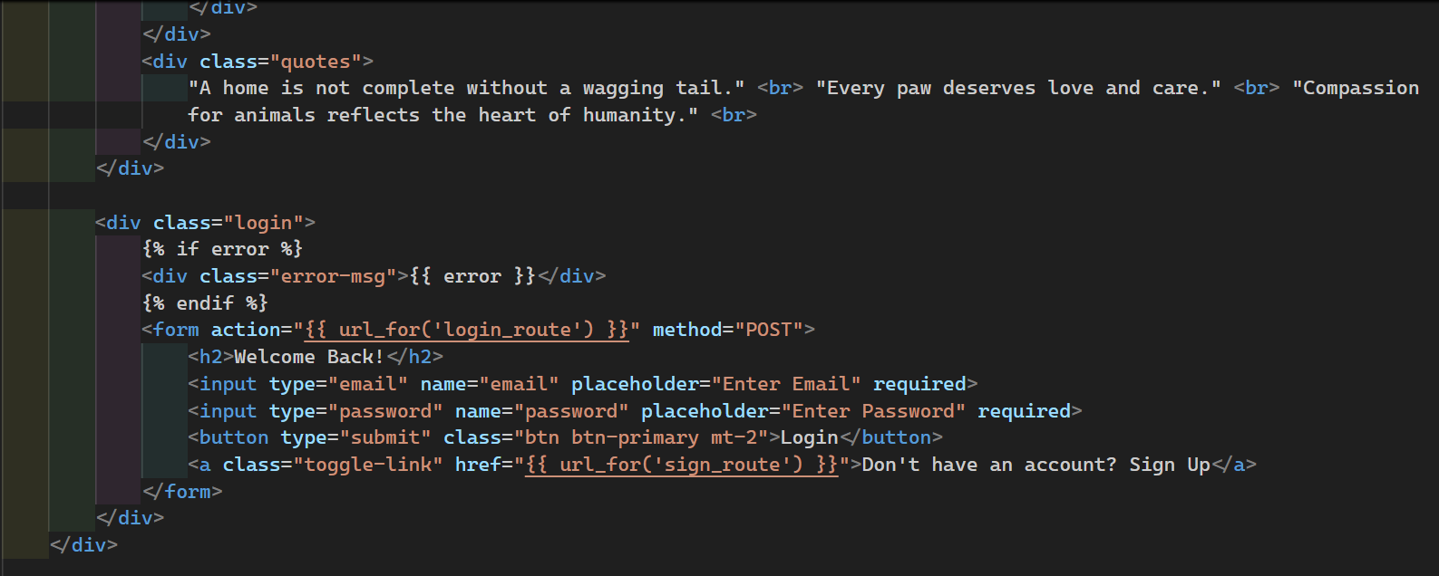

4.2 Appointment Management
- Users can browse a list of available doctors and submit appointment requests.
Doctors can review incoming requests and either approve or reject them.
Approved appointments include an online meeting link for remote consultation.
All status updates are displayed on the user dashboard.

4.3 Prescription Viewing
- Doctors can upload prescriptions for completed consultations.
Users can view prescriptions associated with their previous appointments through a simple interface.

4.4 Health Analysis Module
- The user can input pet-related health values such as weight, height, water intake, and activity level.
The system evaluates these values and provides basic textual suggestions based on 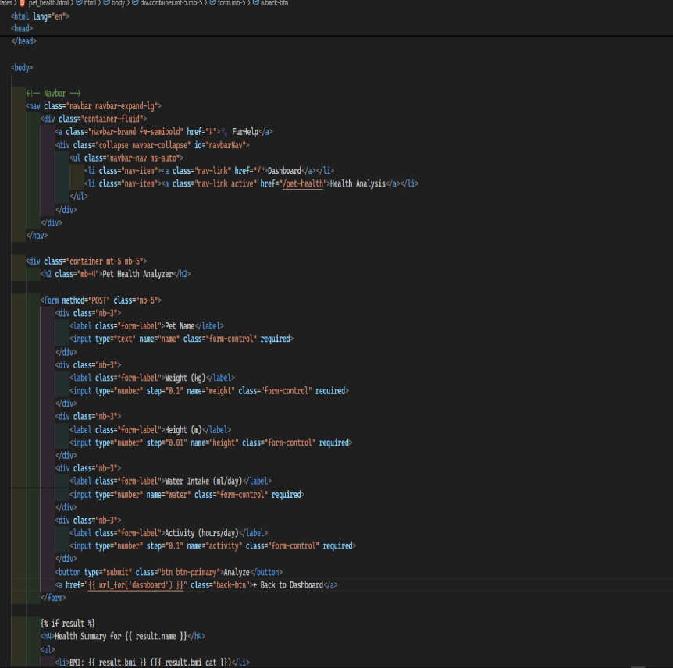common health ranges.

4.5 UI and Dashboard
- The interface includes clickable dashboard items for appointments, prescriptions, vaccination, and health analysis.
Navigation is kept simple to make the system user-friendly, especially for pet owners accessing it from mobile devices.
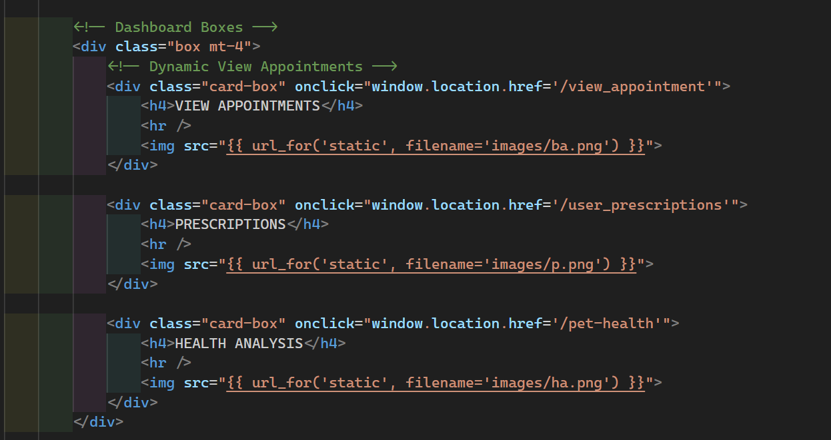

5. RESULTS AND SNAPSHOTS
- Figure 1.1: User/Doctor Login Page
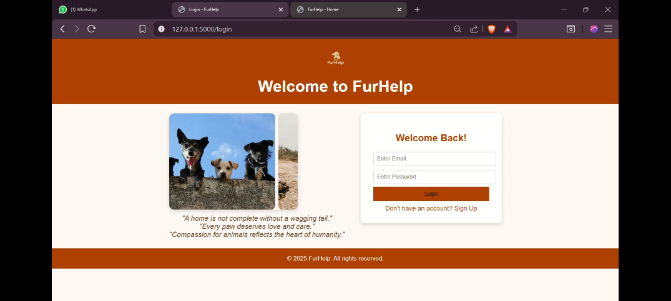
- Figure 1.2: Homepage with Disease Cards
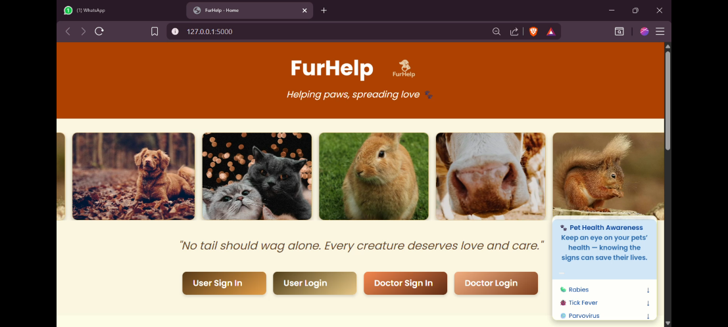
- Figure 1.3: User dashboard
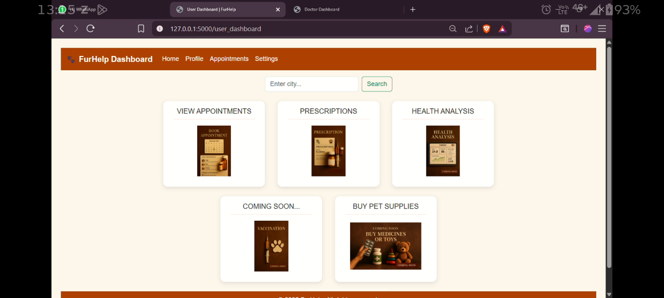

- Figure 1.4: Appointment Booking Form
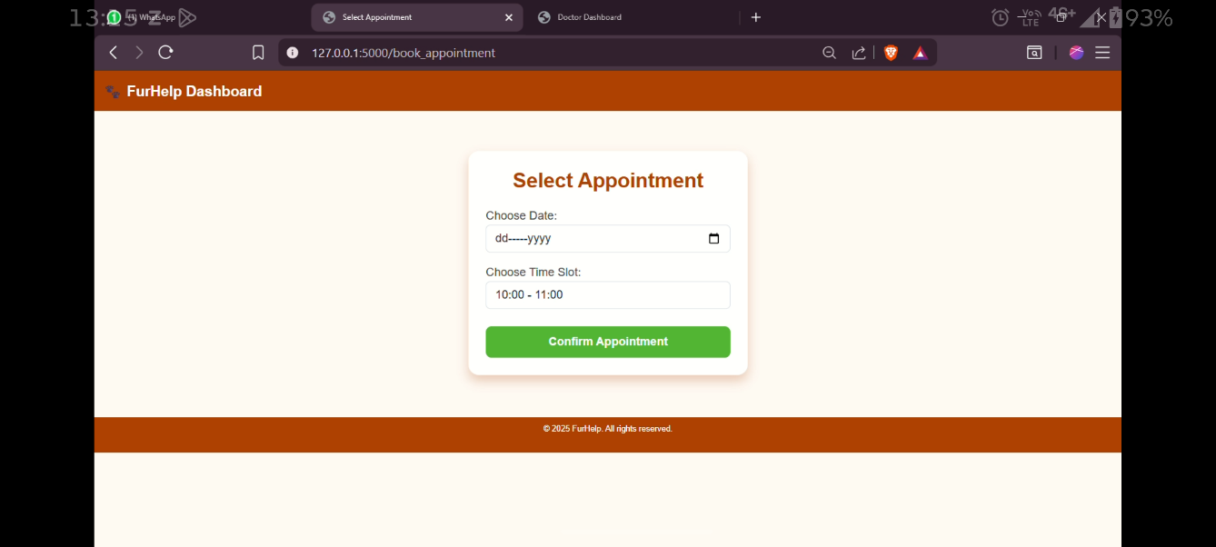
- Figure 1.5: Doctor Dashboard with Approve/Reject Options
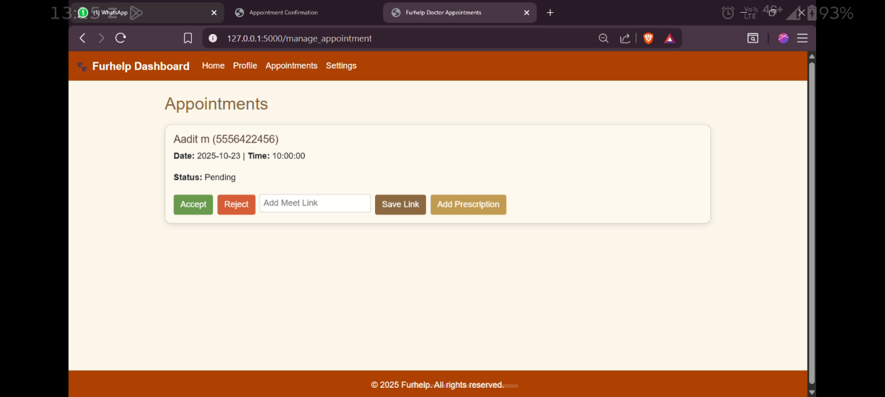

- Figure 1.6: Meeting Link Display
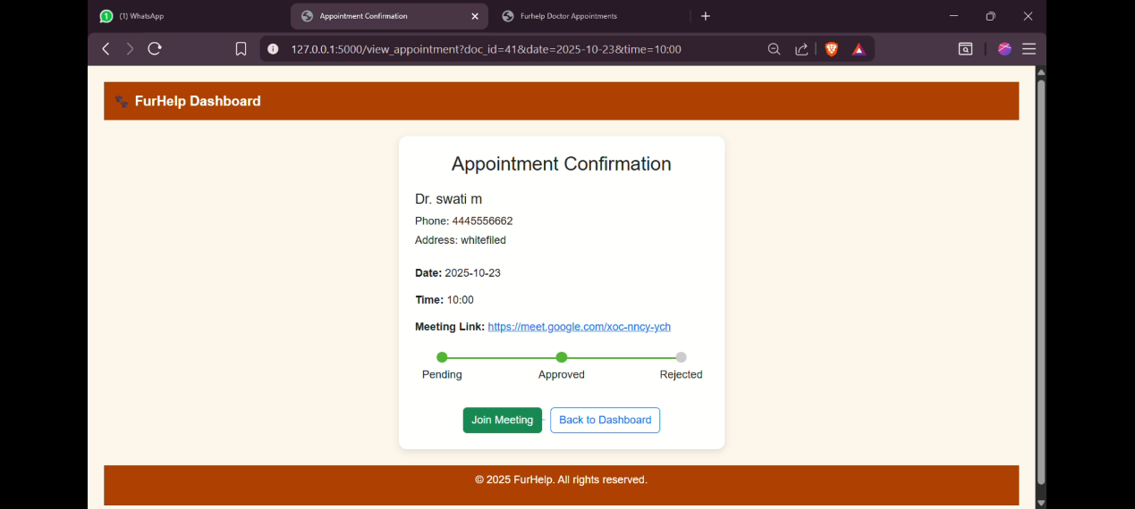
- Figure 1.7: Prescription View Page
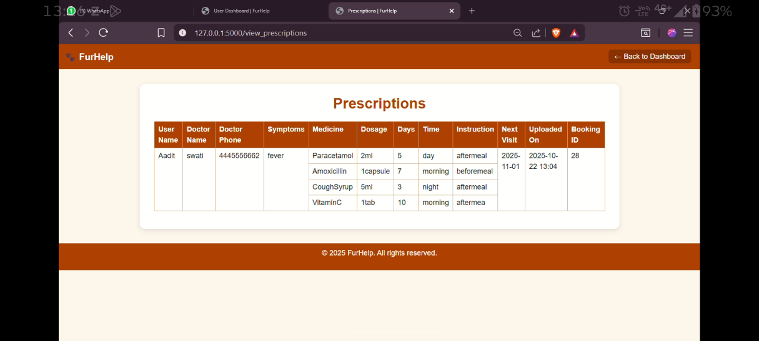
- Figure 1.8: Health Analysis Output
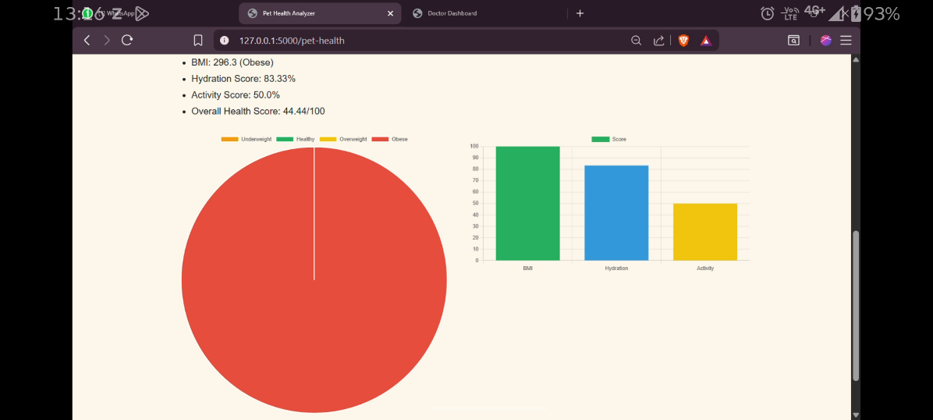

FUTURE SCOPE
1. expansion of advanced features
As technology continues to evolve rapidly, the online pet consultation system has significant potential for future growth. One of the most important areas of future improvement is adding advanced features that enhance both usability and accuracy. For example, integrating AI-based symptom checking tools can help owners receive instant preliminary guidance before connecting with a veterinarian. These tools can analyze symptoms entered by users and provide suggestions by comparing them with known medical patterns. This would not only reduce the workload of veterinarians but also give pet owners clarity during emergencies.
Another major feature that can be included is the real-time video consultation option. Currently, most consultation systems rely on chat or image uploads. But in future video consultations can help veterinarians visually examine the pet’s posture, breathing, injuries, or behavioral changes. Additionally, adding voice call integration can help users who find texting difficult or slow. The platform can also provide multi-language support, allowing pet owners from different linguistic backgrounds to communicate comfortably with veterinarians. This broadens accessibility and creates a more inclusive platform.
2. Integration of artificial intelligence (AI) and machine learning (ML)
The future of online consultations will be deeply influenced by AI and ML technologies. For the online pet consultation system, these technologies can play a transformative role. AI algorithms can be trained using large datasets of veterinary cases to identify common health problems in pets. In the future, the platform can implement AI-based driven diagnosis suggestions, where the system predicts possible issues based on symptoms, images and pet history.
Machine learning can help in predictive analytics, where the system analyzes previous records to predict vaccination dates, possible health risks, or recurring conditions. For instance, if a dog frequently suffers from skin allergies during monsoon season, the ML system can automatically alert the owner before the problem becomes severe. AI can also assist in image analysis, such as identifying skin infections, tick pressure, redness, wounds, or abnormal eye conditions through uploaded images. The automated detection system would dramatically improve diagnosis.
Furthermore, AI chatbots can be implemented to answer common pet-care queries instantly, reducing the waiting time. These bots could guide users on routine care such as diet suggestions, basic first-ad, grooming, and preventive measures. With continuous learning, the chatbot becomes more accurate and more personalized. These future enhancements can significantly elevate the system into a smart, automated, and highly interactive platform.
3. expansion to mobile application development
In future this, project can be extended beyond a web-application into a fully developed android and iOS mobile app. Since most users prefer mobile access due to convenience, a mobile app would improve user engagement and accessibility. Mobile applications can provide instant notifications for appointment remainders, prescription updates, vaccination alerts, and new messages from veterinarians.
Another advantage of a mobile application is the ability to use built-in hardware features such as camera, GPS, and sensors. For example, pet owners can easily upload high-quality images or videos of their pets using their mobile camera. GPS integration can help users find nearby veterinary clinics or emergency centres during critical situations. Push notifications can keep users updated without needing to open the app frequently.
Additionally, mobile apps support offline features, such as strong basic care guidelines, diet charts, and vaccination schedules locally on the device. Each if the user has no internet access temporarily, they can still view essential information. Future versions of the application can also include QR-based pet identification, where each pet has a unique code linking to its medical history. This feature can be extremely useful during emergencies or if the pet gets lost.
4. interaction with smart devices and iot
One of the most exciting possibilities for future development is the integration of smart devices and iot. As smart pet accessories become popular such as smart collars, trackers, automatic feeders, and health monitoring wearables the system can connect with these devices to gather real-time health-data.
For example:
- Smart collars can monitor temperature, heartbeat, and activity levels.
- GPS trackers show the pet’s exact location.
- Smart feeders can monitor eating habits.
- Motion sensors detect unusual behavior patterns.
This information can be directly synced to the online consultation system. Veterinarians can then access accurate, real-time reports that help them diagnose issues more effectively. For instance, sudden drops in activity can indicate illness, while increased scratching behavior can signal allergies or skin issues. Iot- enabled integration would make the platform highly advanced and data-driven.
In future upgrades, smart pet wearables could even alert the owner and veterinarian when Abnormal readings are detected. This automated health monitoring would ensure that pets receive immediate attention, reducing risks and improving overall well-being.
5. integration with government and veterinary regulatory systems
In the long-term future, the online pet consultation system can be connected with official government databases and veterinary regulatory bodies. This would increase authenticity, transparency, and trust among users. For example, government veterinary departments maintain digital records of vaccinations, disease outbreaks, animal census, and breeder registrations. Integrating these datasets with the system would allow real-time validation of vaccination status and help owners stay compliment with official guidelines.
Additionally, linking the system with authorized veterinarian registries ensures that only certified professionals provide consultation through platform. Pet owners can verify the veterinarian’s license, specialization, experience, and certifications. This reduces misinformation and builds user confidence.
The platform can also participate in national digital initiatives. For example, future government programs may introduce centralized digital health IDs for animals, similar to human digital health records. If such systems become common, this platform can support automatic synchronization of pet health history, making the system part of the national animal health ecosystem. This integration contributes to better disease tracking, faster reporting of epidemics, and improved coordination during emergencies like rabies outbreaks.
6. advanced appointment and clinic management system
Another major area of future development is the expansion of the system into a full-fledged veterinary clinic management platform. Beyond online consultation, the system can evolve into a software that clinics use for daily operations. This includes:
- Advanced appointment scheduling
- Automated remainders via SMS, email, or WhatsApp
- Prescription generation and digital signature
- Billing and invoice management
- Inventory monitoring for medicines and vaccines
- Digital storage of health records and diagnostic reports
Future versions may allow veterinarians to maintain branches, manage staff roles, track patient queues, and monitor clinic performance through dashboards and analytics. Clinic owners can analyze trends such as peak consultation times, commonly diagnosed issues, and medication usage. These insights help clinics operate more efficiently.
Additionally, the system can support integration with laboratory services. When a veterinarian requests a test, the lab can upload the results directly into platform. This avoids reduces paperwork, and ensures that reports are safely stored in the pet’s medical history.
7. telemedicine law compliance and legal documentation
As online veterinary consultation grows, governments are likely to introduce new telemedicine regulations. The system can be upgraded to comply with future legal standards. This includes maintaining proper consent documents, privacy agreements, and consultation logs. The platform may also automate the generation of legal records such as:
- E-prescriptions meeting legal guidelines
- Consultation summaries
- Treatment consent forms
- Case history reports for official use
Future upgrades can include automatic legal compliance checking, where the system warns veterinarians if a prescribed treatment or action violates regional telemedicine rules. This feature protects both the veterinarian and the user.
In addition, the system can store digital signatures, maintain timestamped logs, and encrypt communication to meet legal requirements. As laws evolve, the platform can adapt automatically through software updates, ensuring long-term reliability and compliance.

8.expanding to specialized pet care domains
The current system focuses on general veterinary advice, but future versions can expand to cover specialized fields such as:
- Pet nutrition consultation
- Animal behavior therapy
- Grooming and hygiene guidance
- Breeding and reproductive health
- Senior pet care and chronic illness management
Specialists in each domain can join the platform to offer targeted services. For example, behavior therapists can analyze video clips to identify anxiety, aggression, or stress patterns. Nutrition specialists can create personalized meal plans based on breed, weight, allergies, and lifestyle. Grooming experts can assist with coat maintenance, parasite treatment, and hygiene tips.
This specialization enhances the platform’s value and positions it as a comprehensive pet-care ecosystem rather than a simple consultation system.
9. development of a community-based knowledge platform
In future versions, the consultation system can evolve into a full community platform where pet owners, veterinarians, trainers, and pet-care experts interact. This section would act as a digital ecosystem for sharing experiences, advice, and practical solutions to common problems. A community space could include features like:
- Discussion forums for pet owners
- Question-answer sections where experts respond
- Educational articles, blogs, and expert-written guides
- User-generated content, such as sharing photos of conditions for peer awareness
- Success stories and recovery experiences to encourage pet owners
This type of knowledge-sharing environment helps users learn more quickly and makes the system more engaging. It also reduces the dependency on direct consultations for minor doubts. In the long run, a database of pet-care information will develop originally as more users contribute.
Additionally, community voting systems can identify highly helpful posts or answers, ensuring quality content rises to the top. Over time, this knowledge base can serve as valuable resource for new pet owners, veterinary students, and researchers.
10. addition of emergency support and rapid response features
A major limitation in many existing systems is the lack of real-time emergency response. In the future, the platform can incorporate emergency features to address critical health situations quickly and efficiently. These may include:
- A dedicated “emergency help” button
- Automatic connection to the nearest available veterinarian
- Real-time video/voice call activation
- Guided steps for basic first aid
- Information on nearest hospitals, 24x7 clinics, and ambulance services
The system can also use location data to suggest nearby emergency centers. Another important feature could be real-time symptom severity detection. For example, if the user enters symptoms like breathing difficulty or unconsciousness, the system can immediately categorize the case as high risk and recommendation urgent action.
In the long term, partnerships can be built with veterinary emergency units to ensure faster response. The system may even support integration with animal rescue organizations, enabling quick reporting of injured or abandoned animals in public areas. This ensures the platform contributes to both domestic pet care and border animal welfare.
11. incorporation of data analytics and veterinary insights
Analytics will play a crucial role in future expansions. The platform can collect anonymized data (with user permission) to identify trends such as:
- Common health issues across regions
- Seasonal diseases affecting, and treatments
- Recovery in diet, vaccinations, and treatments
- Recovery timelines based on breed and age
These insights can be displayed in dashboards for veterinarians, researchers, and policymakers. For example, if data shows that certain areas experience high cases of tick fever during specific months, authorities may initiate awareness campaigns or preventive measures.
12. expansion into global and multi country deployment
Currently, the system may be designed for a local regional audience, but future upgrades can expand it to global markets. This includes supporting:
- Multiple languages
- Different currencies
- Time zone management
- International veterinary guidelines
- Country specific laws for telemedicine
A global platform would allow users from different countries to connect with veterinarians of their choice. International experts could offer specialized guidance, especially in rare conditions or advanced treatments.
13. integration of payment gateways and subscription models
As the system matures, it can be expanded into a commercially sustainable platform by introducing secure payment solutions and subscription models. Future enhancements may include:
a. online payment gateways
the platform can integrate widely used payment methods are:
- UPI
- Credit/debit cards
- Net banking
- Wallets like Paytm, Google pay, and PhonePe
This will allow users to pay consultation fees directly through the system. A secure payment gateway ensures fast transactions and helps maintain transparency between pet owners and veterinarians.
b. subscription-based services
To offer premium features, the system can introduce subscription plans such as:
- Monthly/yearly premium membership
- Priority consultation packages
- Unlimited chat access with veterinarians
- Discounted emergency consultations
- Access to premium educational content
Subscription models will help in generating consistent revenue while offering long-term value to regular users.
c. digital invoices and medical billing
The platform can generate:
- Automated bills
- Downloadable invoices
- Payment history logs
- Tax/GST compliant receipts
These features help pet owners keep organized medical and financial records, which can be useful for insurance claims or long-term tracking of medical expenses.
14. partnership with veterinary clinics, universities and NGOs
Future development can include building formal partnerships with:
- Veterinary hospitals
- Private clinics
- Veterinary colleges
- NGOs and animal shelters
- Pet-care service providers
a. collaboration with veterinary clinics
Clinics can use the system to:
- Manage appointments
- Track patient records
- Provide online follow-up consultations
- Share lab test results
This improves their operational efficiently and reduces paperwork.

b. support from veterinary colleges
Veterinary colleges can contribute by:
- Reviewing medical content
- Providing expert advice
- Publishing research-based guidelines
- Allowing interns to assist in non-emergency online consultations
This gives students practical exposure and ensures the platform maintains medical accuracy.
c. NGO integration
Animal welfare organizations can use the system to report:
- Injured street animals
- Lost and found pets
- Aware ness campaigns
By building these partnerships, the platform becomes more credible and impactful in society. In the long run, it may evolve into a nationally recognized digital veterinary support ecosystem.
15. implementation of electronic health records(EHR) for pets:
A highly promising future feature is the integration of electronic health records for animals. Just like humans have digital medical records, pets can also benefit from a structured, long-term health history stored securely online.
EHR features includes:
- Vaccination timelines
- Growth charts
- Medical history and prescriptions
- Previous consultations
- Lab test results
- Diet and nutrition plans
Benefits:
- Veterinarians get fast access to the pet’s complete health information
- Owners avoid misplacing physical documents
- Better decision-making during emergency cases
- Easy sharing of records between multiple clinics
- Supports long-term preventive care
Future versions may allow downloadable and sharable EHR reports for easy communication during travel or when visiting new clinics
16. expansion toward preventive healthcare modules
The future goal is to shift from only curative consultation to preventive healthcare. Advanced modules can be added to remind and educate pet owners about maintaining good health proactively.
Possible preventive-care features:
- Vaccination remainders
- Deworming schedules
- Parasite prevention alerts
- Diet and nutrition recommendations
- Seasonal disease alerts
- Grooming remainders
- Behavioral monitoring tips
The system can also send automated alerts based on breed, age, climate, and medical history. For example:
- Long-haired breeds may get grooming remainders
- Senior pets may get arthritis or joint-care alerts
- Breeds prone to obesity may receive dietary guidelines
By focusing on preventive care, future versions long-term pet wellness and reduce emergency cases.

CONCLUSION
The online pet consultation system successfully demonstrates how digital technology can be used to improve accessibility and convenience in the field of veterinary care. The project brings together essential wen development tools-HTML, CSS, Bootstrap, JavaScript, Python, and MySQL to create a platform where pet owners can easily register, submit queries, and receive guidance from veterinary experts. Through this system, users are able to overcome common barriers such as long travel distances, lack of nearby clinics, and time limitations, making it easier to seek timely advice for their pets.
The project also highlights the importance of organized data management and a responsive interface in building efficient online services. By storing user information, pet details, and consultation history in a structured database, the system ensures reliability and continuity in communication. The implementation of a clean and user-friendly interface further enhances the experience, allowing even non-technical users to interact with the platform without difficulty.
From a broader perspective, this system contributes to growing trend of digital healthcare solutions. As research has shown, online consultations especially in veterinary services help reduce unnecessary physical visits and promote early detection of problems. This project adds to that field by providing a simple yet purposeful platform tailored to the needs of pet owners. Although the current version focuses mainly on basic consultations features, it sets a strong foundation for future improvements such as video consultations, AI-based symptom checking, mobile apps, and integration with smart devices.
Overall, the project demonstrates the effectiveness of combing software development skills with real-world problem solving. It only fulfills the project objectives but also shows how digital platforms can support better pet health management. With continued development and more advanced features, the online pet consultation system has the potential to become a comprehensive and widely used tool for improving animal healthcare in the future.

REFERENCES
- Wadhwa, R. (2020). Telemedicine and online consultation systems: A review of emerging trends. International journal of digital health, 5(2), 45-33.
- Sharma, A., & Gupta, M. (2021). Web-based healthcare platforms and their impact on accessibility. Journal of health informatics, 14(1), 22-30.
- Brown, T. (2019). Digital transformation in veterinary services. Veterinary technology review, 8(3), 67-75.
- Singh, K., & Reddy S. (2020). Role of AI and web technologies in modern web application. International journal of computer science engineering, 12(4), 110-118.
- Patel, N. (2021). User interface and user experience design principles in web development. Journal of web engineering, 9(2), 55-64.
- Kumar, A., & Mehta, R. (2019). Application of python in backend web development. International journal computing, 18(1), 89-96.
- MySQL Documentation. (2022). MySQL Workbench: database design and administration guide. Oracle corporation.
- World organization for animal health (OIE). (2020). Guidelines on veterinary telemedicine. OIE publications.
- Anderson, L. (2020). Pet health management and early disease detection. Journal of veterinary research, 11(2), 120-132.
- Bootstrap documentation. (2022). Bootstrap 5: Responsive web design framework Guide. Retrieved from https://getbootstrap.com
- Mozilla developer network. (2022). HTML, CSS, and JavaScript web development resources. Retrieved from https://developer.mozilla.org
- Python software foundation. (2022). Python programming language documentation.
Retrieved from https://www.python.org

